Attributes or properties of ModelAmin

The following attributes or properties are used for customization model interface provided by admin.

- list_display : shows selected fields in list display (OR) while displaying data (OR) displaying model data in list view/rows and columns

admin.py

from django.contrib import admin
from app.models import Student
# Register your models here.

class StudentAdminModel(admin.ModelAdmin):
list_display=['rollno','name','course','fee']

admin.site.register(Student,StudentAdminModel)

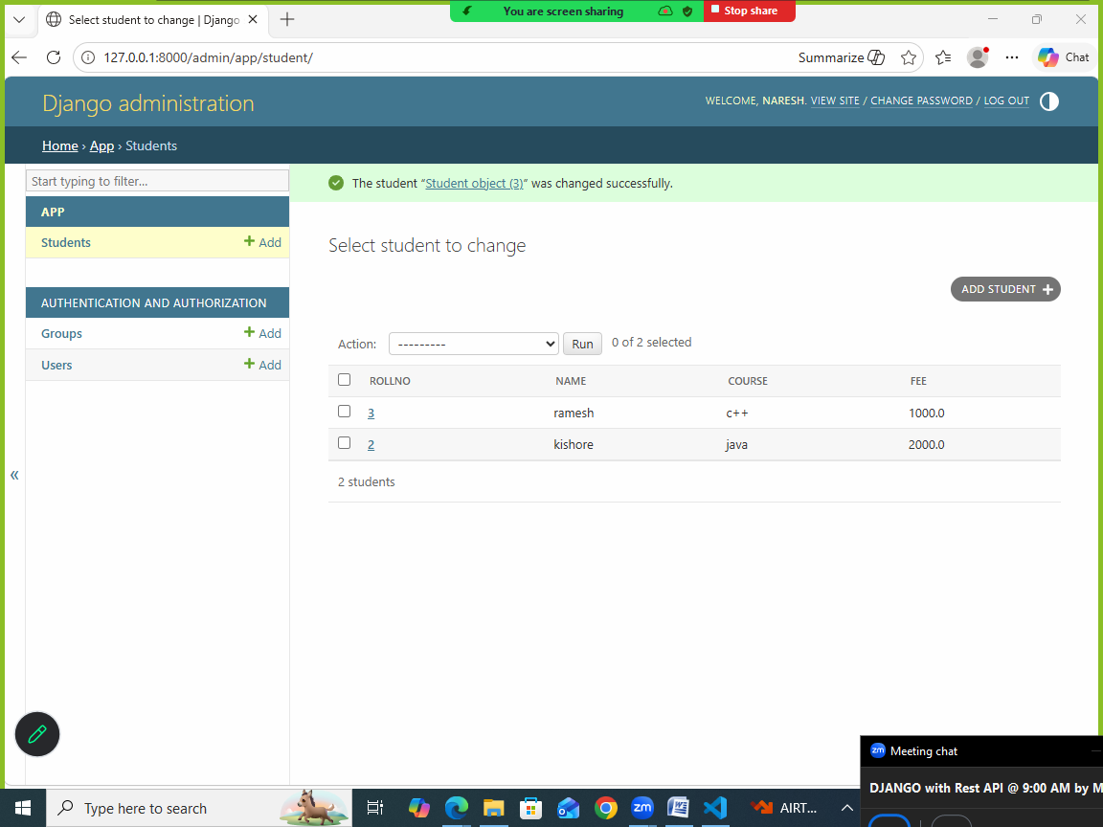

- search_fields : enable search option, which allows search or list data based on search value

admin.py
from django.contrib import admin
from app.models import Student
# Register your models here.

class StudentAdminModel(admin.ModelAdmin):
list_display=['rollno','name','course','fee']
search_fields=['name','course']

admin.site.register(Student,StudentAdminModel)

- list_filter : set/add sidebar filters

admin.py

from django.contrib import admin
from app.models import Student
# Register your models here.

class StudentAdminModel(admin.ModelAdmin):
list_display=['rollno','name','course','fee']
search_fields=['name','course']
list_filter=['name','course']

admin.site.register(Student,StudentAdminModel)

- ordering : this attribute define the order of displaying data. It display in ascending or descending order specific column/field

ordering=[‘column-name’] 🡪 display in ascending order
ordering=[‘-column-name’] 🡪 display in descending order

from django.contrib import admin
from app.models import Student
# Register your models here.

class StudentAdminModel(admin.ModelAdmin):
list_display=['rollno','name','course','fee']
ordering=['name']

admin.site.register(Student,StudentAdminModel)

- readonly_fields : This attribute disable fields for modification or updation.

from django.contrib import admin
from app.models import Student
# Register your models here.

class StudentAdminModel(admin.ModelAdmin):
list_display=['rollno','name','course','fee']
readonly_fields=['rollno','name']

admin.site.register(Student,StudentAdminModel)

- actions: actions is defined method/function to be executed on selected records in listview of admin interface

admin.py

from django.contrib import admin
from app.models import Student
# Register your models here.

class StudentAdminModel(admin.ModelAdmin):
list_display=['rollno','name','course','fee']
actions=['mark_students_freecourse']

def mark_students_freecourse(self,request,queryset):
queryset.update(course='free course')

admin.site.register(Student,StudentAdminModel)

- list_editable: This attribute/property allows edit values in listview only

from app.models import Student
# Register your models here.

class StudentAdminModel(admin.ModelAdmin):
list_display=['rollno','name','course','fee']
list_editable=['course','fee']

admin.site.register(Student,StudentAdminModel)

Creating users and giving permissions using admin interface

Login with admin

- Create user

- Adduser
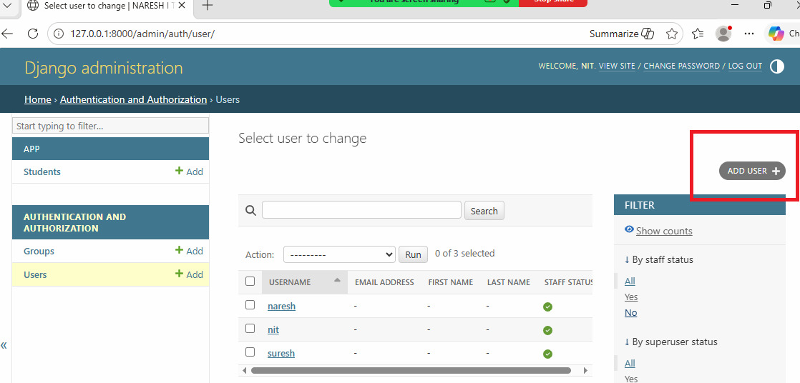

- Input user details

Creating groups
A group is collection of users

Login as admin

- Click on groups
- Add group

Select users
- Edit user
- Add group name

